COS40007 Artificial Intelligence Engineering

Portfolio Assessment 2: Electrical Grid Stability Classification
Student Name | Hoang Huu Hoan
Student ID | 105732188
Task | Portfolio Assessment 2 — Advanced Data Preprocessing, Feature Engineering & Model Development
Dataset | Electrical Grid Stability Simulated Data — Arzamasov (2018), UCI ML Repository, https://doi.org/10.24432/C5PG66
Submission Date | 12 October 2026
Github Repo | https://github.com/henryhoang207/COS40007-Porfollio-Task

Acknowledgement of Country
I acknowledge the Wurundjeri People of the Kulin Nation as Traditional Owners of the lands where Swinburne's Australian campuses are located, and pay respect to Elders past and present. I also acknowledge Traditional Owners across Australia. This adapts Swinburne's institutional acknowledgement; it does not assume that this analysis was completed on an Australian campus. Source: Swinburne Moondani Toombadool Centre.

Generative AI declaration

I use GenAI to assist with structuring the analysis code, suggesting data-quality checks, debugging, improving code readability, and comments and plot labelling. All final code, interpretations, and conclusions are my own work after verification.

Problem, provenance and Task 1 evidence
Can reaction times, consumer powers and price elasticities classify simulated four-node grid operating conditions as stable or unstable? Each row is a simulated configuration of one central producer and three consumers, not a timestamped field measurement.
The source is Arzamasov (2018), Electrical Grid Stability Simulated Data, UCI, DOI 10.24432/C5PG66, licensed CC BY 4.0. The preserved CSV is copied without alteration from the Task 1 artifacts. Task 1 Section 4 / Figure 4 found uniform original predictors; Section 5 / Figures 6-8 motivated the aggregate, interaction and fast-response hypotheses. Copies of three relevant Task 1 evidence tables accompany this work.
Task 1 examined the whole dataset before this split. The holdout therefore has prior exploratory exposure and is not untouched external validation. Feature hypotheses are fixed from that existing EDA; fitted transformations and rankings are learned inside each current training fold.

Task 1: Target preparation and data audit
The applicable categorical-target branch is retained: stable = 0, unstable = 1. No numerical binning is needed. Neither class exceeds the plan's 80% severe-imbalance threshold, so no resampling is used. Accuracy is supplemented by balanced accuracy, macro-F1 and both recalls.
stab is excluded because its sign determines stabf. p1 is excluded for continuity with Task 1 because it is the negative sum of consumer powers; this is redundancy, distinct from target leakage. All remaining 11 inputs are continuous, so no categorical predictor encoding is required.
{
"rows": 10000,
"missing_cells": 0,
"duplicate_rows": 0,
"duplicate_configurations": 0,
"label_sign_disagreements": 0,
"maximum_power_balance_error": 5.773159728050814e-15,
"source_sha256": "7afc3154fed9cd65258b3403b60381fe6b0d832bf817a1ea4866395d05a84a83"
}

 | Class | Code | Count | Percent
0 | stable | 0 | 3620 | 36.2
1 | unstable | 1 | 6380 | 63.8

 | Variables | Action | Reason / units
0 | tau1-tau4 | Keep | Reaction times; seconds
1 | p2-p4 | Keep | Consumer powers; inverse seconds squared
2 | g1-g4 | Keep | Elasticities; inverse seconds
3 | p1 | Exclude | Redundant: -(p2+p3+p4)
4 | stab | Exclude | Target leakage: sign determines the label
5 | stabf | Target only | Map stable=0, unstable=1

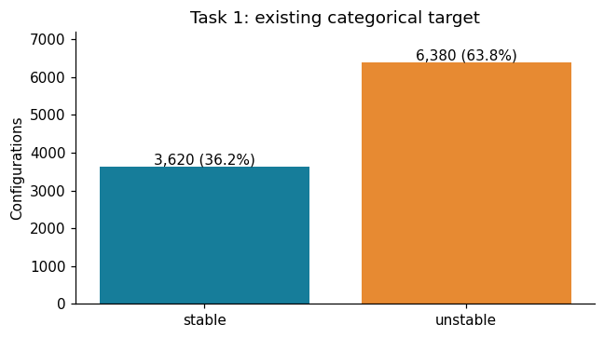

Evaluation protocol (locked before comparisons)
Use one stratified 70/30 split, seed 42: 7,000 development and 3,000 holdout rows. All models share five shuffled stratified outer development folds. Tuned SVMs use five inner folds (seed 43) on each outer training partition, then one full-development search for the final model. The inner winning score is a selection score, not the outer evaluation score.
Rank by mean development CV accuracy. Define a near tie as at most 0.2 percentage points below the best mean; prefer fewer resulting features/components, then fewer support vectors for SVMs, then higher mean accuracy. This rule is applied before holdout prediction. Error bars are fold SD (sample SD, ddof=1), not confidence intervals. CV balanced accuracy, macro-F1 and recalls are also saved. Model-family selection can still be optimistic; the fixed holdout provides a separate final check within the already-explored simulated dataset.
 | Split | accuracy | balanced_accuracy | macro_f1 | stable_recall | unstable_recall
0 | development | 0.638 | 0.5 | 0.3895 | 0.0 | 1.0
1 | holdout | 0.638 | 0.5 | 0.3895 | 0.0 | 1.0

 | Split | Rows | Stable | Unstable
0 | development | 7000 | 2534 | 4466
1 | holdout | 3000 | 1086 | 1914

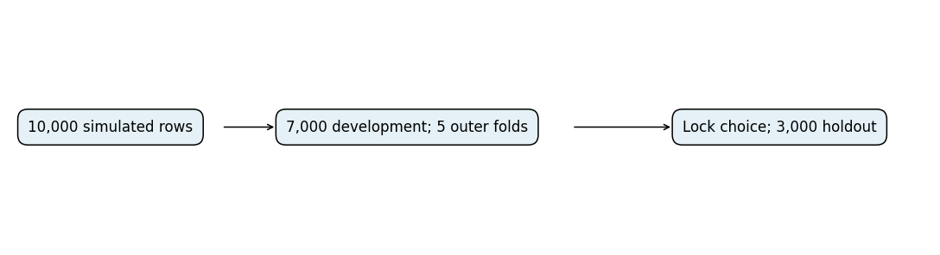

Task 2: Normalisation and encoding
Task 1 Section 4 / Figure 4 and distribution_check.csv support MinMaxScaler for each original uniform predictor. This changes range, not distribution shape. Trees generally keep the same split ordering under monotonic scaling; scaling alone is not claimed to improve their accuracy. SVM distances and PCA are scale-sensitive. No predictor needs one-hot or ordinal encoding.
The two node means use StandardScaler because aggregation makes their development distributions more bell-shaped. The skewed product uses MinMaxScaler. The bounded fast-node fraction retains its natural [0,1] scale. These choices are fixed before comparisons. The displays below fit a separate descriptive scaler only on development data; model pipelines learn their own scalers within every fold. A holdout value just outside [0,1] is possible and does not justify refitting.

 | Feature | Action | Skew
0 | tau1 | MinMaxScaler | 0.0023
1 | tau2 | MinMaxScaler | 0.0113
2 | tau3 | MinMaxScaler | 0.0038
3 | tau4 | MinMaxScaler | 0.0063
4 | p2 | MinMaxScaler | 0.0078
5 | p3 | MinMaxScaler | 0.0055
6 | p4 | MinMaxScaler | 0.0064
7 | g1 | MinMaxScaler | 0.0069
8 | g2 | MinMaxScaler | -0.0101
9 | g3 | MinMaxScaler | -0.0155
10 | g4 | MinMaxScaler | 0.0115
11 | tau_mean | StandardScaler | 0.0163
12 | g_mean | StandardScaler | 0.0155
13 | tau_g_interaction | MinMaxScaler | 0.5038
14 | fast_node_fraction | Natural [0,1] | 0.5332

 | Feature | Before min | Before max | Before mean | Before SD
0 | tau1 | 0.5008 | 9.9995 | 5.2469 | 2.7475
1 | tau2 | 0.5001 | 9.9998 | 5.2319 | 2.7495
2 | tau3 | 0.5008 | 9.9995 | 5.2578 | 2.7403
3 | tau4 | 0.5005 | 9.9994 | 5.2426 | 2.7271
4 | p2 | -1.9997 | -0.5001 | -1.2500 | 0.4314
5 | p3 | -1.9997 | -0.5001 | -1.2561 | 0.4335
6 | p4 | -1.9999 | -0.5000 | -1.2507 | 0.4338
7 | g1 | 0.0500 | 0.9999 | 0.5231 | 0.2743
8 | g2 | 0.0501 | 0.9999 | 0.5263 | 0.2747
9 | g3 | 0.0501 | 1.0000 | 0.5268 | 0.2728
10 | g4 | 0.0500 | 0.9999 | 0.5221 | 0.2739
11 | tau_mean | 0.8764 | 9.3079 | 5.2448 | 1.3787
12 | g_mean | 0.1195 | 0.9355 | 0.5245 | 0.1365
13 | tau_g_interaction | 0.3844 | 7.0953 | 2.7548 | 1.0408
14 | fast_node_fraction | 0.0000 | 1.0000 | 0.2630 | 0.2209

 | Feature | After min | After max | After mean | After SD
0 | tau1 | 0.0000 | 1.0000 | 0.4997 | 0.2893
1 | tau2 | 0.0000 | 1.0000 | 0.4981 | 0.2894
2 | tau3 | 0.0000 | 1.0000 | 0.5008 | 0.2885
3 | tau4 | 0.0000 | 1.0000 | 0.4992 | 0.2871
4 | p2 | 0.0000 | 1.0000 | 0.5000 | 0.2877
5 | p3 | 0.0000 | 1.0000 | 0.4959 | 0.2891
6 | p4 | 0.0000 | 1.0000 | 0.4995 | 0.2892
7 | g1 | 0.0000 | 1.0000 | 0.4980 | 0.2888
8 | g2 | 0.0000 | 1.0000 | 0.5013 | 0.2893
9 | g3 | 0.0000 | 1.0000 | 0.5018 | 0.2871
10 | g4 | 0.0000 | 1.0000 | 0.4969 | 0.2884
11 | tau_mean | -3.1687 | 2.9473 | -0.0000 | 1.0001
12 | g_mean | -2.9678 | 3.0109 | 0.0000 | 1.0001
13 | tau_g_interaction | 0.0000 | 1.0000 | 0.3532 | 0.1551
14 | fast_node_fraction | 0.0000 | 1.0000 | 0.2630 | 0.2209

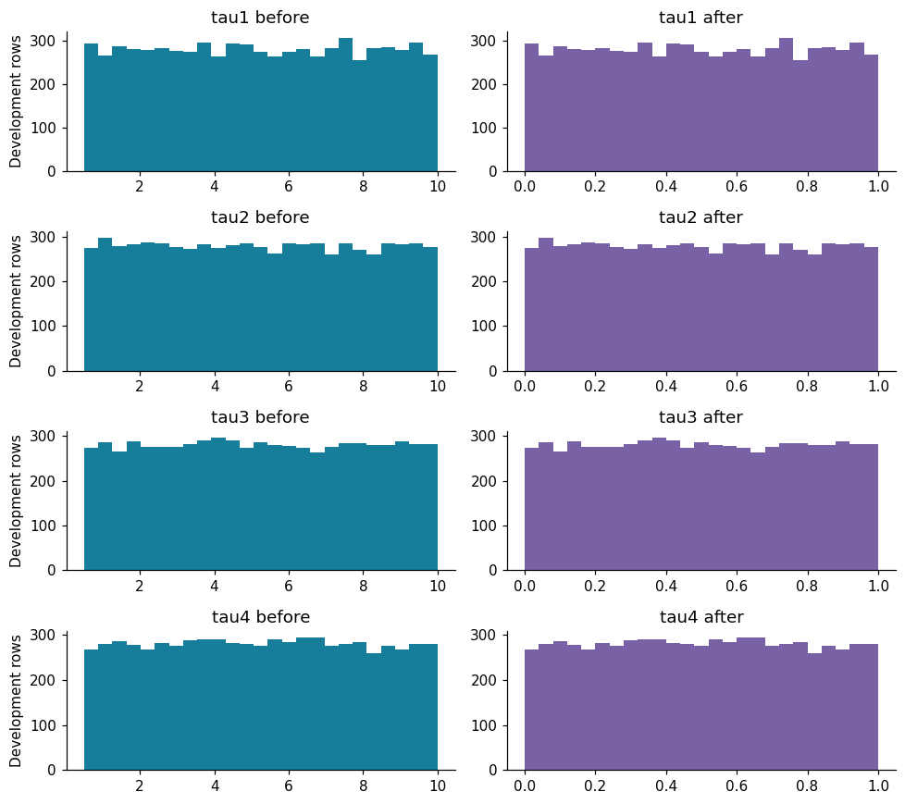
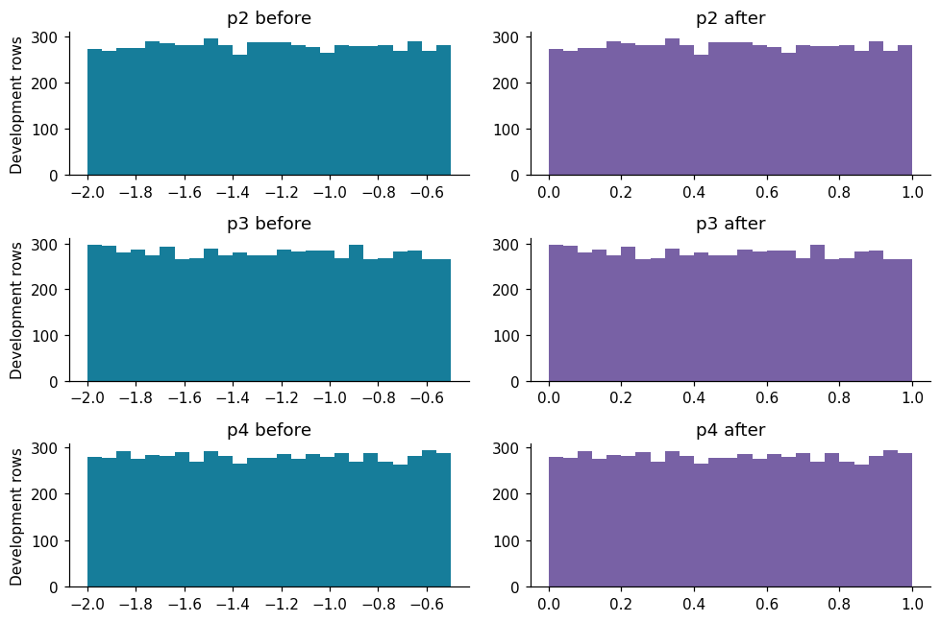
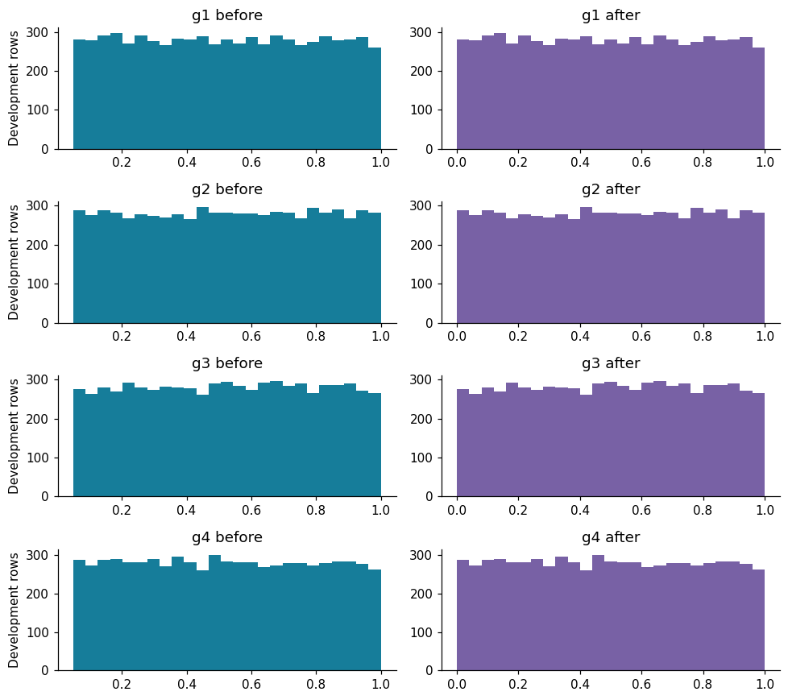
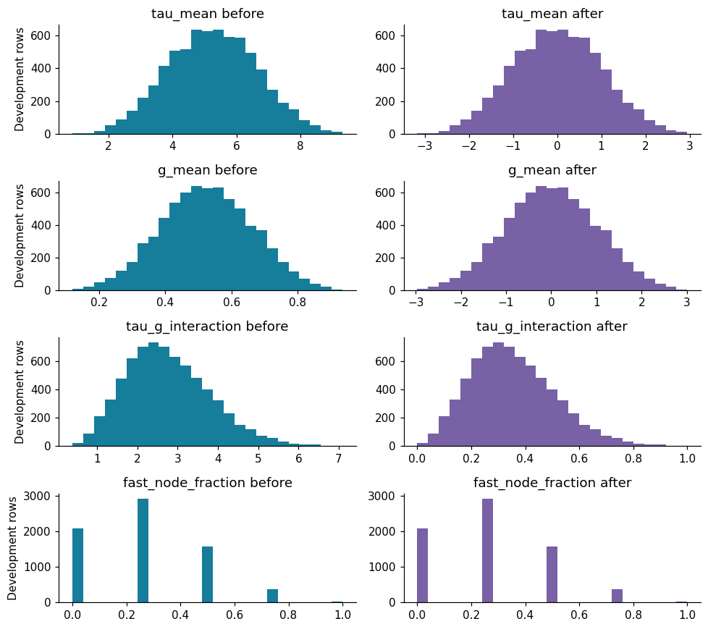
The retained original predictors have approximately symmetric, flat distributions. The feature-specific before/after tables use development rows only. StandardScaler uses population SD (ddof=0), so the displayed sample SD can differ slightly from 1. The fast-node fraction is discrete at 0, 0.25, 0.5, 0.75 and 1.

Task 3: Four features grounded in existing EDA
Feature | Formula and units | Exact Task 1 link and meaning
tau_mean | (tau1+tau2+tau3+tau4)/4; seconds | Section 5 Figure 8: aggregate reaction delay
g_mean | (g1+g2+g3+g4)/4; inverse seconds | Section 5 Figure 8: average price-response sensitivity
tau_g_interaction | tau_mean*g_mean; dimensionless | Section 5 Figure 8: joint delay/elasticity pattern
fast_node_fraction | count(tau_i <= 3 s)/4; dimensionless | Section 5 Figures 6-7: fast-response region

The 3-second threshold is a fixed approximate EDA hypothesis, not a physical safety limit. The product is a predictive composite, not a proven stability law. Each feature is validated below using development-only associations, class distributions and binned unstable rates. These analyses are descriptive; no p-value is used to select or redesign a feature after viewing the holdout.

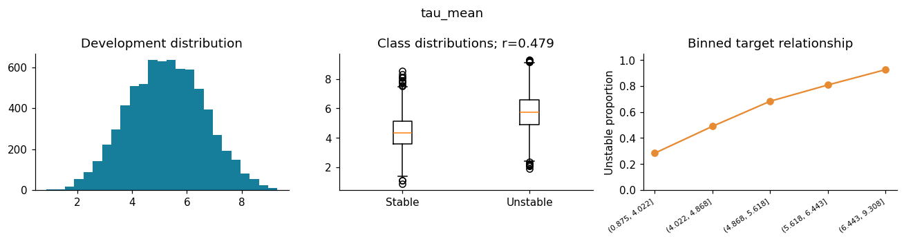
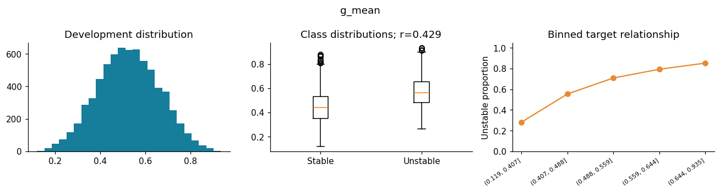
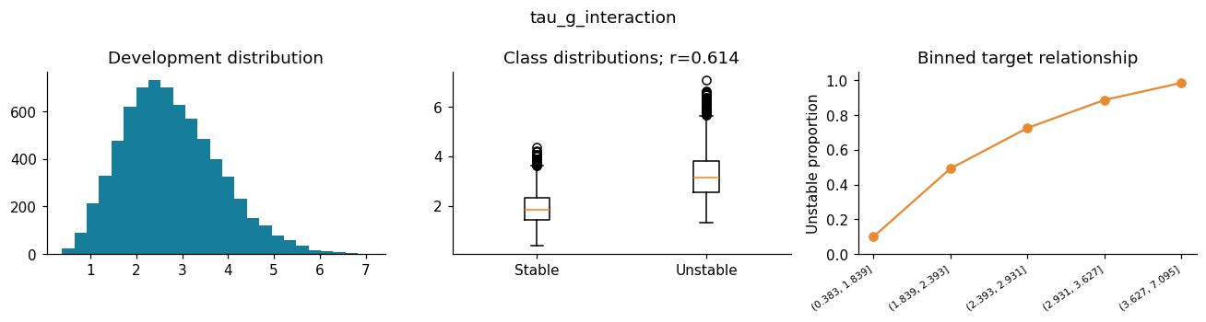
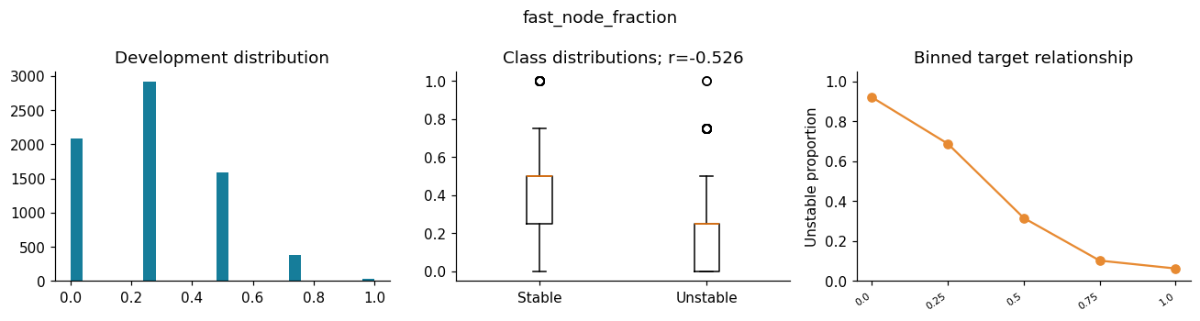

 | Feature | Point-biserial r | Stable mean | Unstable mean
0 | tau_mean | 0.4793 | 4.3676 | 5.7425
1 | g_mean | 0.4293 | 0.4468 | 0.5687
2 | tau_g_interaction | 0.6145 | 1.9058 | 3.2366
3 | fast_node_fraction | -0.5262 | 0.4172 | 0.1754

 | Feature A | Feature B | Correlation
0 | tau_mean | tau_g_interaction | 0.7087
1 | tau_mean | fast_node_fraction | -0.7664
2 | g_mean | tau_g_interaction | 0.6966

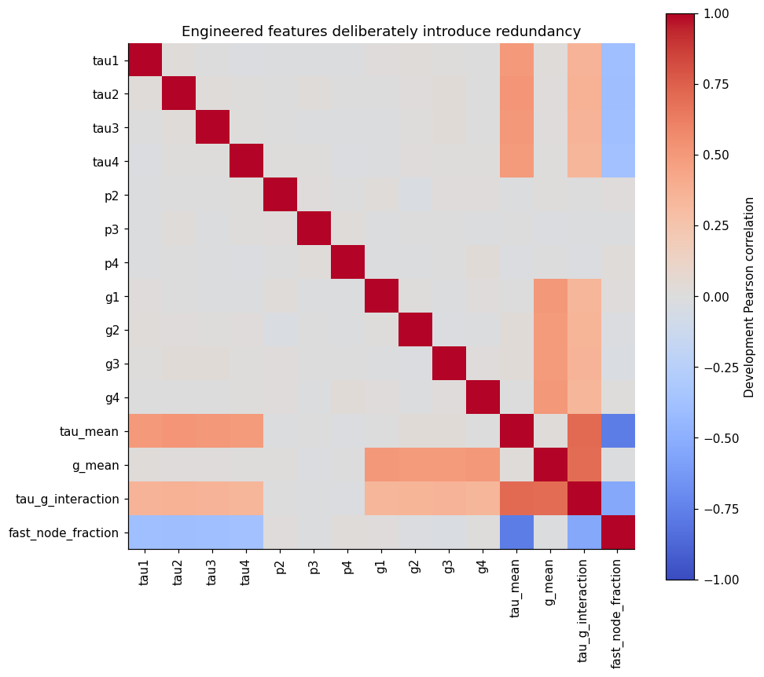
All four feature hypotheses expose aggregated or threshold structure. Their signs and binned patterns should be interpreted together: linear correlation alone misses saturation. The means share information with their component inputs, and the product shares information with both means. A large importance for one of these variables does not establish causation or make correlated alternatives unimportant.

Task 4: Exactly five Decision Tree configurations
Use the same DecisionTreeClassifier(random_state=42) defaults in all five configurations: Gini criterion, unrestricted depth, minimum split 2, minimum leaf 1, no pruning. Studio 3 defaults were unavailable. This is a controlled representation comparison, not tree hyperparameter tuning.
ID | Representation | Purpose
DT1 | 11 original inputs | Baseline
DT2 | Five original inputs ranked by absolute point-biserial correlation inside each fit | Compact marginal subset
DT3 | 11 originals and four engineered inputs | Collective engineering test
DT4 | Five PCA components from MinMax-scaled originals | Unsupervised compression test
DT5 | tau1-tau4 and g1-g4 | Domain subset without consumer powers

The majority reference is not a sixth tree. Training accuracy diagnoses overfitting, not generalisation. Permutation importance is computed on the first outer validation fold for the chosen tree, so no holdout feedback changes feature design. It remains descriptive after model selection.
DT1 complete; CV accuracy 0.8307

DT2 complete; CV accuracy 0.7311

DT3 complete; CV accuracy 0.8344

DT4 complete; CV accuracy 0.6773

DT5 complete; CV accuracy 0.8403

 | Fold | Selected
0 | 1 | tau2, tau3, g3, tau1, tau4
1 | 2 | tau2, tau3, tau1, g3, tau4
2 | 3 | tau2, tau3, tau1, g3, tau4
3 | 4 | tau2, tau3, g3, tau1, tau4
4 | 5 | tau2, g3, tau1, tau4, tau3
5 | Full development | tau2, tau3, g3, tau1, tau4

 | Model | Features | Train accuracy | CV accuracy | CV SD | Final fit s | CV total s
0 | DT1 | 11 | 1.0 | 0.8307 | 0.0134 | 0.0614 | 0.4554
1 | DT2 | 5 | 1.0 | 0.7311 | 0.0126 | 0.0527 | 0.3051
2 | DT3 | 15 | 1.0 | 0.8344 | 0.0131 | 0.0936 | 0.4377
3 | DT4 | 5 | 1.0 | 0.6773 | 0.0399 | 0.0494 | 0.3388
4 | DT5 | 8 | 1.0 | 0.8403 | 0.0109 | 0.0435 | 0.2305

Best tree selected using development CV: DT5
DT4 five-component variance retained: 0.47272193414364144

 | tau1 | tau2 | tau3 | tau4 | p2 | p3 | p4 | g1 | g2 | g3 | g4 | Component
0 | 0.3876 | 0.2576 | 0.2703 | 0.0739 | -0.3364 | -0.2415 | -0.4270 | -0.0044 | 0.5105 | 0.0225 | -0.2999 | 1
1 | -0.1820 | 0.4606 | 0.4518 | 0.1789 | 0.0877 | 0.2303 | -0.0112 | -0.3829 | -0.2309 | 0.5077 | -0.0054 | 2
2 | -0.2304 | 0.0194 | -0.1603 | 0.1454 | -0.3720 | 0.4709 | 0.2584 | -0.4215 | 0.2461 | -0.3621 | -0.3218 | 3
3 | 0.5022 | 0.4421 | -0.1146 | -0.4298 | -0.1302 | 0.2115 | 0.4924 | 0.1211 | 0.0396 | 0.0810 | 0.1659 | 4
4 | 0.0279 | 0.2993 | -0.2381 | 0.1327 | 0.4578 | 0.4731 | -0.2912 | 0.4262 | 0.0117 | -0.0736 | -0.3605 | 5

 | Feature | Impurity importance
2 | tau3 | 0.1379
1 | tau2 | 0.1316
3 | tau4 | 0.1313
4 | g1 | 0.1263
0 | tau1 | 0.1233
7 | g4 | 0.1224
6 | g3 | 0.1203
5 | g2 | 0.1068

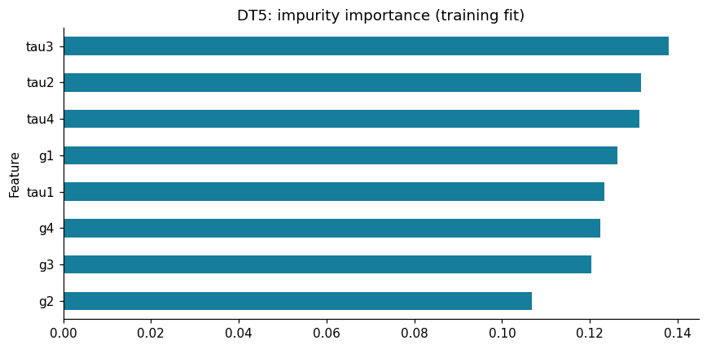
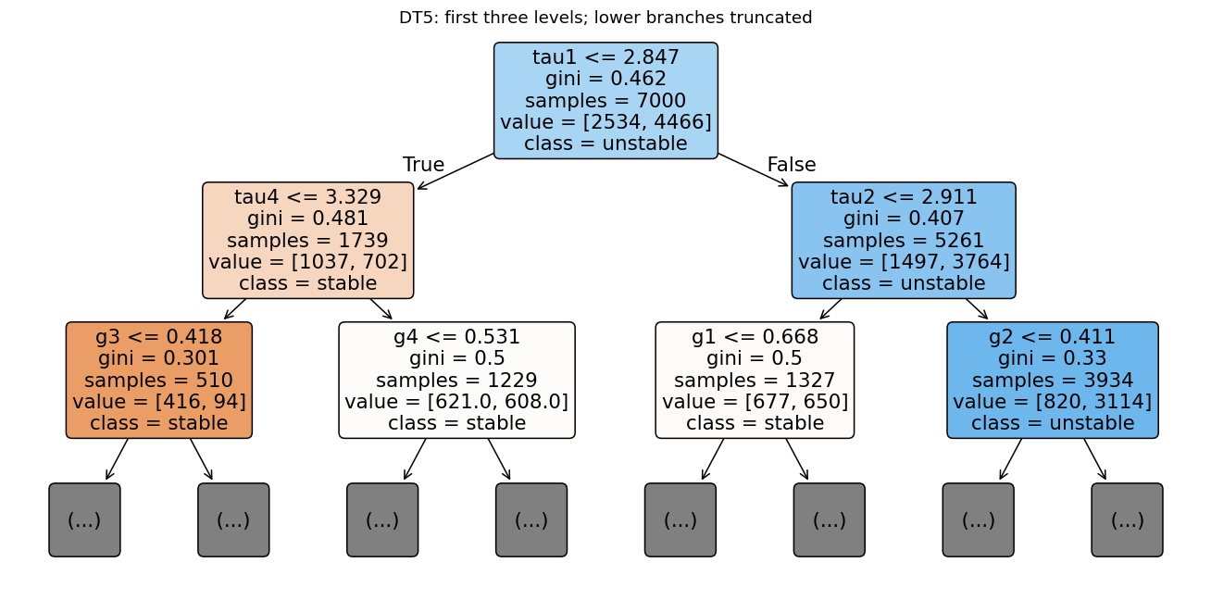
 | Raw input | Accuracy decrease | Repeat SD
1 | tau2 | 0.0667 | 0.0034
0 | tau1 | 0.0604 | 0.0063
3 | tau4 | 0.0597 | 0.0046
2 | tau3 | 0.0593 | 0.0055
9 | g3 | 0.0563 | 0.0057
10 | g4 | 0.0530 | 0.0021
8 | g2 | 0.0474 | 0.0029
7 | g1 | 0.0460 | 0.0065
6 | p4 | 0.0000 | 0.0000
4 | p2 | 0.0000 | 0.0000
5 | p3 | 0.0000 | 0.0000

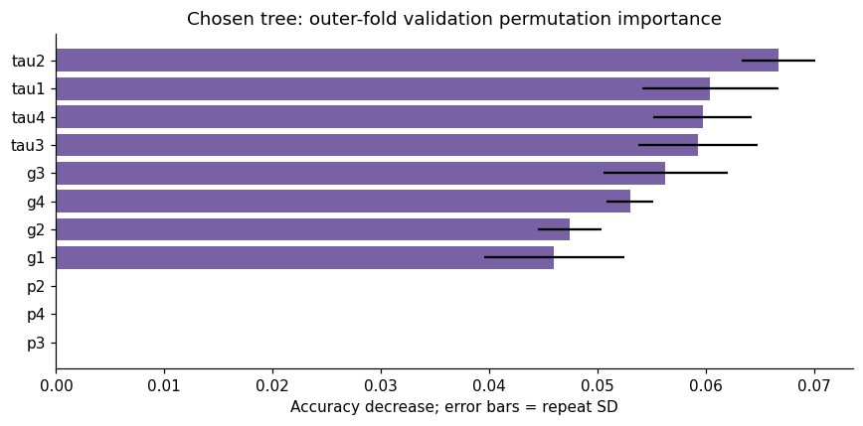
DT5 was selected from development CV. Its most important fitted split feature is tau3. Impurity importance favours variables offering useful training splits and can split credit among redundant inputs. Permuting a raw input through the pipeline also recomputes any derived features that use it; this measures input-level sensitivity, not the isolated contribution of one engineered feature. The tree diagram shows only its top levels.

Tasks 6-9: SVM specification before final comparison
The fixed 15-feature pool is used for all four variants, independent of which tree wins. SVM1 uses default RBF SVC (C=1, gamma='scale'). SVM2 searches the same pool, SVM3 jointly searches SelectKBest K and SVC settings, and SVM4 jointly searches PCA retained variance and SVC settings.
The initial grid uses linear C in [0.1,1,10,100], and RBF with the same C values and gamma in ['scale',0.01,0.1,1]. Separate dictionaries avoid searching meaningless gamma values for linear SVC. Larger C penalises errors more strongly; gamma controls RBF locality. K in [3,5,8,11,'all'] tests compression and the unreduced option. ANOVA f_classif ranks marginal class separation and can miss joint interactions. PCA variance thresholds [0.90,0.95,0.99] use the full solver. PCA is unsupervised: retained input variance does not guarantee retained class information.
Bounded boundary policy. If an initial inner winner has C=100, test C=1000 for that winning kernel, retaining all gamma choices for RBF. If the initial RBF winner has gamma=0.01 or 1, test respectively 0.001 or 10 with all original C values. The union is evaluated inside that same inner training search. Selection/PCA variants use all their original representation choices in the extension. One extension per search is allowed; unresolved boundaries are disclosed. This rule is fixed before holdout evaluation and used consistently inside every outer fold and the full-development search. Initial and extension records are both saved.
A timing pilot (7,000 rows; MinMax proxy for the full pool) measured about 3.39 seconds for linear C=100 and 0.46 seconds for RBF C=10, gamma=1. It only estimated runtime and did not select features or parameters. Grid counts and actual full search time appear below.

 | Model | Initial candidates | Inner folds | Outer folds | Full-development searches
0 | SVM2 | 20 | 5 | 5 | 1
1 | SVM3 | 100 | 5 | 5 | 1
2 | SVM4 | 60 | 5 | 5 | 1

SVM2 [{"svc__kernel": ["linear"], "svc__C": [0.1, 1, 10, 100]}, {"svc__kernel": ["rbf"], "svc__C": [0.1, 1, 10
, 100], "svc__gamma": ["scale", 0.01, 0.1, 1]}]
SVM3 [{"svc__kernel": ["linear"], "svc__C": [0.1, 1, 10, 100], "select__k": [3, 5, 8, 11, "all"]}, {"svc__kern
el": ["rbf"], "svc__C": [0.1, 1, 10, 100], "svc__gamma": ["scale", 0.01, 0.1, 1], "select__k": [3, 5, 8, 11,
"all"]}]
SVM4 [{"svc__kernel": ["linear"], "svc__C": [0.1, 1, 10, 100], "pca__n_components": [0.9, 0.95, 0.99]}, {"svc_
_kernel": ["rbf"], "svc__C": [0.1, 1, 10, 100], "svc__gamma": ["scale", 0.01, 0.1, 1], "pca__n_components":
[0.9, 0.95, 0.99]}]
Starting SVM1

SVM1 outer fold 1 accuracy 0.8964

SVM1 outer fold 2 accuracy 0.9093

SVM1 outer fold 3 accuracy 0.9057

SVM1 outer fold 4 accuracy 0.9229

SVM1 outer fold 5 accuracy 0.9079

Completed SVM1 full development; settings {'svc__C': 1, 'svc__kernel': 'rbf', 'svc__gamma': 'scale'}

Starting SVM2

SVM2 outer fold 1 accuracy 0.9536

SVM2 outer fold 2 accuracy 0.9514

SVM2 outer fold 3 accuracy 0.9507

SVM2 outer fold 4 accuracy 0.9621

SVM2 outer fold 5 accuracy 0.9529

Completed SVM2 full development; settings {'svc__C': 1000, 'svc__gamma': 0.1, 'svc__kernel': 'rbf'}

Starting SVM3

SVM3 outer fold 1 accuracy 0.9536

SVM3 outer fold 2 accuracy 0.945

SVM3 outer fold 3 accuracy 0.9571

SVM3 outer fold 4 accuracy 0.9636

SVM3 outer fold 5 accuracy 0.9571

Completed SVM3 full development; settings {'select__k': 11, 'svc__C': 1000, 'svc__gamma': 'scale', 'svc__kerne
l': 'rbf'}

Starting SVM4

SVM4 outer fold 1 accuracy 0.955

SVM4 outer fold 2 accuracy 0.9521

SVM4 outer fold 3 accuracy 0.9536

SVM4 outer fold 4 accuracy 0.9643

SVM4 outer fold 5 accuracy 0.9543

Completed SVM4 full development; settings {'pca__n_components': 0.99, 'svc__C': 1000, 'svc__gamma': 0.1, 'svc_
_kernel': 'rbf'}

 | Model | Features | Train accuracy | CV accuracy | CV SD | Support vectors | Final search/fit s | Outer total s
0 | SVM1 | 15 | 0.9269 | 0.9084 | 0.0095 | 2251 | 0.4933 | 3.1285
1 | SVM2 | 15 | 0.9896 | 0.9541 | 0.0046 | 893 | 42.5841 | 151.0866
2 | SVM3 | 11 | 0.9984 | 0.9553 | 0.0068 | 636 | 270.3766 | 834.4618
3 | SVM4 | 11 | 0.9854 | 0.9559 | 0.0048 | 869 | 136.8206 | 496.8993

Recommendation locked before holdout: SVM3

 | Model | Fold | Features/components | Inner selection accuracy | Outer accuracy
0 | SVM1 | 1 | 15 | NaN | 0.8964
1 | SVM1 | 2 | 15 | NaN | 0.9093
2 | SVM1 | 3 | 15 | NaN | 0.9057
3 | SVM1 | 4 | 15 | NaN | 0.9229
4 | SVM1 | 5 | 15 | NaN | 0.9079
5 | SVM2 | 1 | 15 | 0.9486 | 0.9536
6 | SVM2 | 2 | 15 | 0.9521 | 0.9514
7 | SVM2 | 3 | 15 | 0.9521 | 0.9507
8 | SVM2 | 4 | 15 | 0.9450 | 0.9621
9 | SVM2 | 5 | 15 | 0.9511 | 0.9529
10 | SVM3 | 1 | 11 | 0.9582 | 0.9536
11 | SVM3 | 2 | 11 | 0.9629 | 0.9450
12 | SVM3 | 3 | 11 | 0.9552 | 0.9571
13 | SVM3 | 4 | 11 | 0.9562 | 0.9636
14 | SVM3 | 5 | 11 | 0.9573 | 0.9571
15 | SVM4 | 1 | 11 | 0.9471 | 0.9550
16 | SVM4 | 2 | 11 | 0.9514 | 0.9521
17 | SVM4 | 3 | 11 | 0.9500 | 0.9536
18 | SVM4 | 4 | 11 | 0.9468 | 0.9643
19 | SVM4 | 5 | 11 | 0.9470 | 0.9543

 | Model | balanced_accuracy | macro_f1 | stable_recall | unstable_recall
0 | DT1 | 0.8155 | 0.8163 | 0.7605 | 0.8706
1 | DT2 | 0.7107 | 0.7100 | 0.6366 | 0.7848
2 | DT3 | 0.8194 | 0.8203 | 0.7648 | 0.8739
3 | DT4 | 0.6533 | 0.6526 | 0.5663 | 0.7403
4 | DT5 | 0.8257 | 0.8266 | 0.7727 | 0.8786
5 | SVM1 | 0.8960 | 0.8999 | 0.8508 | 0.9411
6 | SVM2 | 0.9494 | 0.9503 | 0.9321 | 0.9666
7 | SVM3 | 0.9515 | 0.9516 | 0.9376 | 0.9653
8 | SVM4 | 0.9516 | 0.9522 | 0.9361 | 0.9671

Tasks 7-9: Tuning, feature selection and PCA diagnostics
The following diagnostics use full-development inner selection results, distinctly labelled from outer evaluation. K curves show the best inner score per K after optimising SVC settings; they are not independent generalisation estimates. Exact selected features and PCA loadings are retained.

 | Model | Kernel | C | Gamma | K / variance | Inner accuracy
0 | SVM1 | rbf | 1 | scale | all | NaN
1 | SVM2 | rbf | 1000 | 0.1 | all | 0.9517
2 | SVM3 | rbf | 1000 | scale | 11 | 0.9594
3 | SVM4 | rbf | 1000 | 0.1 | 0.99 | 0.9537

SVM2 top full-development inner candidates:

 | params | mean_test_score | std_test_score
0 | {'svc__C': 1000, 'svc__gamma': 0.1, 'svc__kern... | 0.9517 | 0.0086
1 | {'svc__C': 100, 'svc__gamma': 'scale', 'svc__k... | 0.9509 | 0.0093
2 | {'svc__C': 100, 'svc__gamma': 0.1, 'svc__kerne... | 0.9461 | 0.0060
3 | {'svc__C': 1000, 'svc__gamma': 'scale', 'svc__... | 0.9457 | 0.0064
4 | {'svc__C': 10, 'svc__gamma': 'scale', 'svc__ke... | 0.9413 | 0.0085

SVM3 top full-development inner candidates:

 | params | mean_test_score | std_test_score
0 | {'select__k': 11, 'svc__C': 1000, 'svc__gamma'... | 0.9594 | 0.0076
1 | {'select__k': 11, 'svc__C': 1000, 'svc__gamma'... | 0.9549 | 0.0060
2 | {'select__k': 11, 'svc__C': 100, 'svc__gamma':... | 0.9536 | 0.0074
3 | {'select__k': 11, 'svc__C': 1000, 'svc__gamma'... | 0.9520 | 0.0087
4 | {'select__k': 'all', 'svc__C': 1000, 'svc__gam... | 0.9517 | 0.0086

SVM4 top full-development inner candidates:

 | params | mean_test_score | std_test_score
0 | {'pca__n_components': 0.99, 'svc__C': 1000, 's... | 0.9537 | 0.0082
1 | {'pca__n_components': 0.99, 'svc__C': 100, 'sv... | 0.9464 | 0.0099
2 | {'pca__n_components': 0.99, 'svc__C': 100, 'sv... | 0.9457 | 0.0083
3 | {'pca__n_components': 0.99, 'svc__C': 1000, 's... | 0.9450 | 0.0085
4 | {'pca__n_components': 0.99, 'svc__C': 10, 'svc... | 0.9423 | 0.0081

 | Feature | ANOVA F | Selected
11 | tau_g_interaction | 4245.1819 | True
14 | fast_node_fraction | 2679.1966 | True
12 | tau_mean | 2087.0516 | True
13 | g_mean | 1580.8529 | True
1 | tau2 | 493.6893 | True
2 | tau3 | 434.1608 | True
9 | g3 | 413.3286 | True
0 | tau1 | 408.5001 | True
3 | tau4 | 394.2561 | True
8 | g2 | 345.8181 | True
10 | g4 | 317.3894 | True
7 | g1 | 274.2205 | False
6 | p4 | 3.8774 | False
5 | p3 | 0.0262 | False
4 | p2 | 0.0090 | False

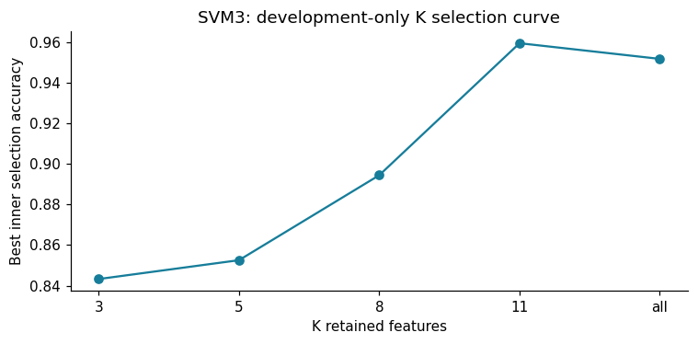
 | Components | Cumulative variance
0 | 1 | 0.3836
1 | 2 | 0.7427
2 | 3 | 0.7723
3 | 4 | 0.8010
4 | 5 | 0.8296
5 | 6 | 0.8579
6 | 7 | 0.8860
7 | 8 | 0.9132
8 | 9 | 0.9401
9 | 10 | 0.9667
10 | 11 | 0.9932
11 | 12 | 0.9998
12 | 13 | 1.0000
13 | 14 | 1.0000
14 | 15 | 1.0000

 | Component | Top absolute loadings
0 | PC1 | tau_mean (+0.794), g_mean (+0.507), tau_g_inte...
1 | PC2 | g_mean (+0.811), tau_mean (-0.508), g1 (+0.122)
2 | PC3 | g2 (+0.543), p2 (-0.377), p4 (-0.357)
3 | PC4 | p4 (+0.561), p3 (+0.536), g2 (+0.328)
4 | PC5 | tau1 (+0.583), g1 (+0.431), tau4 (-0.317)
5 | PC6 | tau4 (+0.530), p2 (+0.415), g1 (+0.378)
6 | PC7 | g4 (+0.504), tau2 (-0.433), tau4 (+0.415)
7 | PC8 | tau3 (+0.717), g1 (+0.309), tau4 (-0.283)
8 | PC9 | tau2 (+0.565), tau1 (-0.495), p3 (-0.450)
9 | PC10 | g4 (+0.441), p2 (+0.408), g3 (-0.380)
10 | PC11 | p2 (+0.529), p4 (+0.458), p3 (-0.377)

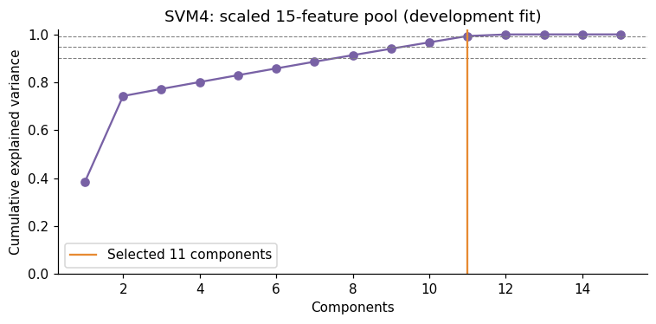
SVM3 selected 11 features: tau1, tau2, tau3, tau4, g2, g3, g4, tau_g_interaction, tau_mean, g_mean, fast_node_fraction. SVM4 retained 11 components and 99.32% of scaled development variance. Loading signs are arbitrary up to a simultaneous component sign flip. These PCA results depend on the explicitly chosen mixed scaling; variance in differently scaled coordinates is not raw physical variance. Fold-specific K, components and settings are saved separately.
After the single bounded extension, remaining search-boundary settings occur in: SVM2, SVM3, SVM4. The search is finite and does not prove globally optimal parameters.

Interpreting the reduction and engineered redundancy
The means introduce exact linear relationships: 4*tau_mean = tau1+tau2+tau3+tau4 and 4*g_mean = g1+g2+g3+g4. Consequently, the 15-feature pool has at most 13 independent linear directions even before considering other correlations. Per-feature affine scaling preserves these dependencies after centering; the complete PCA spectrum can therefore include approximately zero trailing eigenvalues. The product and fast-node fraction add nonlinear representations of existing measurements, rather than new independently measured information.
In the actual SVM3 selection, an omitted node input is reconstructable from retained raw inputs and their mean: g1 = 4*g_mean - g2 - g3 - g4. Thus dropping this named input does not necessarily discard its information. The selected representation changes the geometry seen by the SVM, and removes consumer powers where absent; a better score should not be interpreted as proof that the omitted node has no engineering influence.
K was selected using the prespecified inner CV search, not the final holdout. The selected component/feature count is one measure of representation size; support vectors and fit/search cost describe other aspects of complexity. Both reduction methods still require measuring the inputs used to form retained aggregates or components.

Task 5: First Comparison Table with visuals (five trees)
All nine configurations and the recommendation have now been frozen using development evidence. The holdout is evaluated once per fixed final model below. No parameter or representation is revised after these results. First Comparison Table includes exactly five Decision Tree rows; holdout supporting metrics and SD-labelled development error bars are supplied alongside it.

 | Model | Features | Train accuracy | CV accuracy | CV SD | Holdout accuracy | Final fit s
0 | DT1 | 11 | 1.0 | 0.8307 | 0.0134 | 0.8553 | 0.0614
1 | DT2 | 5 | 1.0 | 0.7311 | 0.0126 | 0.7280 | 0.0527
2 | DT3 | 15 | 1.0 | 0.8344 | 0.0131 | 0.8397 | 0.0936
3 | DT4 | 5 | 1.0 | 0.6773 | 0.0399 | 0.6597 | 0.0494
4 | DT5 | 8 | 1.0 | 0.8403 | 0.0109 | 0.8573 | 0.0435

 | Model | balanced_accuracy | macro_f1 | stable_recall | unstable_recall
0 | DT1 | 0.8466 | 0.8444 | 0.8149 | 0.8783
1 | DT2 | 0.7044 | 0.7049 | 0.6188 | 0.7900
2 | DT3 | 0.8254 | 0.8261 | 0.7735 | 0.8772
3 | DT4 | 0.6375 | 0.6357 | 0.5571 | 0.7179
4 | DT5 | 0.8494 | 0.8467 | 0.8204 | 0.8783

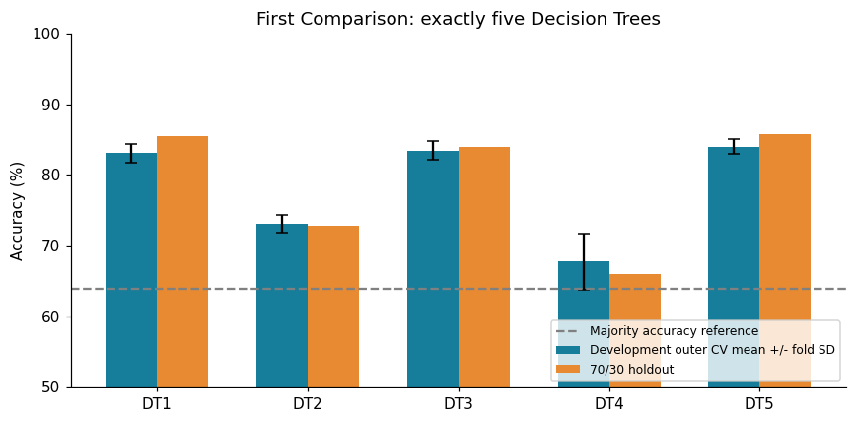
Which representation won? The predeclared rule selected DT5, with mean CV accuracy 84.03%. Did engineering help? DT3 minus DT1 is +0.37 percentage points in CV. What happened without consumer powers? DT5 minus DT1 is +0.96 points. Did PCA lose predictive signal? DT4 minus DT1 is -15.34 points while retaining 47.27% of input variance. Tradeoffs and overfitting: training minus CV gaps range from 15.97 to 32.27 points; unrestricted trees can memorise training configurations. Compact inputs may improve explanation but discard interactions. A single five-fold comparison does not establish statistical significance. [Studio_3_Task_5_Exact_Reflection_Prompts] remain to be reconciled.

Task 10: Final Comparison Table with visuals (four SVM variants)
Accuracy and SD in the following tables are proportions (multiply by 100 for percentages). Supporting metrics are holdout values; CV supporting metrics were displayed earlier. SVM1 has ordinary five-fold CV; SVM2-4 have nested outer five-fold CV. Runtime includes the full-development search and refit where applicable, so it must not be interpreted as inference latency or a like-for-like standalone estimator fit comparison.

 | Model | Features | Train accuracy | CV accuracy | CV SD | Holdout accuracy | Support vectors
0 | SVM1 | 15 | 0.9269 | 0.9084 | 0.0095 | 0.9220 | 2251
1 | SVM2 | 15 | 0.9896 | 0.9541 | 0.0046 | 0.9660 | 893
2 | SVM3 | 11 | 0.9984 | 0.9553 | 0.0068 | 0.9673 | 636
3 | SVM4 | 11 | 0.9854 | 0.9559 | 0.0048 | 0.9640 | 869

 | Model | balanced_accuracy | macro_f1 | stable_recall | unstable_recall
0 | SVM1 | 0.9102 | 0.9146 | 0.8674 | 0.9530
1 | SVM2 | 0.9634 | 0.9632 | 0.9540 | 0.9728
2 | SVM3 | 0.9644 | 0.9646 | 0.9540 | 0.9749
3 | SVM4 | 0.9614 | 0.9611 | 0.9521 | 0.9707

 | Model | Final search/fit s | Outer total s
0 | SVM1 | 0.4933 | 3.1285
1 | SVM2 | 42.5841 | 151.0866
2 | SVM3 | 270.3766 | 834.4618
3 | SVM4 | 136.8206 | 496.8993

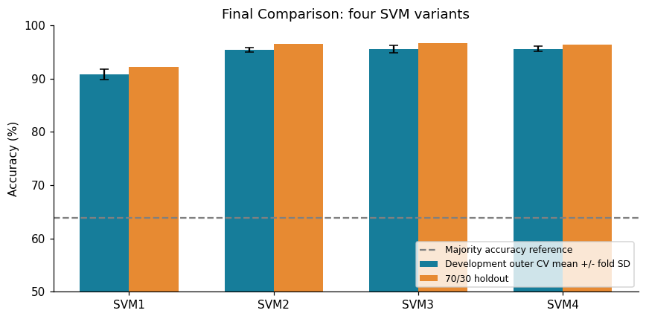
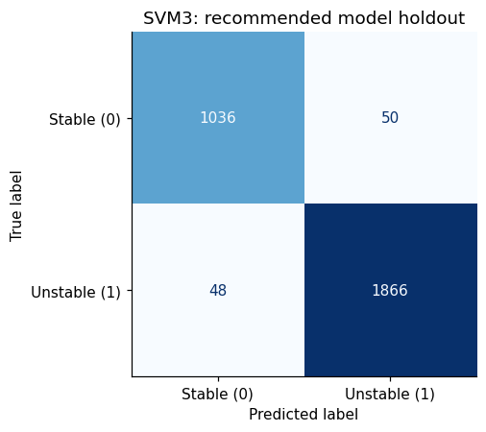
 | Fold | Recommended SVM minus best DT (pp)
0 | 1 | 11.2143
1 | 2 | 11.1429
2 | 3 | 13.1429
3 | 4 | 11.0714
4 | 5 | 10.9286

Did SVM improve on DT? Recommended SVM3 minus DT5 is +11.50 percentage points in development CV and +11.00 points on holdout. Did tuning help? SVM2 minus SVM1 is +4.57 CV points and +4.40 holdout points. Which features survived K-best? tau1, tau2, tau3, tau4, g2, g3, g4, tau_g_interaction, tau_mean, g_mean, fast_node_fraction. K-best minus tuned unreduced SVM2 is +0.11 CV points. Did PCA reduce complexity at acceptable cost? SVM4 uses 11 components from 15 inputs; its CV change from SVM2 is +0.17 points. The recommendation applies the predeclared accuracy and simplicity rule; feature count alone does not measure model complexity, so support vectors and search runtime are also shown.
Which errors are most concerning? With rows=true class and columns=predicted class, the bottom-left entry is 48 unstable cases predicted stable. These false assurances would be the more concerning error in a screening use. The top-right entry is 50 stable cases predicted unstable. Stable recall is 95.40%; unstable recall is 97.49%. No cost weighting or decision threshold was tuned after viewing these errors. An operational deployment would require domain-specific costs and external validation. [Studio_3_Task_10_Exact_Reflection_Prompts] remain to be reconciled.

Conclusion and limitations
The recommendation below is based on development CV with the locked simplicity rule. The holdout provides a subsequent check, and does not choose the winner. Small numerical differences should not be presented as convincing improvements without additional independent evidence.
Limitations include prior full-data Task 1 EDA, simulation-only configurations, one split and one five-fold partition, correlated engineered representations, finite parameter grids, and omitted real-grid dynamics and operating distributions. PCA preserves scaled input variance, not safety; ANOVA selection is univariate; unrestricted trees overfit. Neither the product feature nor a 3-second reaction threshold proves a physical stability criterion. No real-grid generalisation or deployment fitness has been established.
Recommendation: SVM3, with development accuracy 95.53% +/- 0.68% fold SD, holdout accuracy 96.73%, balanced accuracy 96.44% and macro-F1 0.9646. This is the best-supported choice under the specified comparison protocol, not a validated real-grid control system.
Integrity checks passed: five trees; four SVMs; shared split; no excluded inputs; finite CV outputs.

Demonstration: reproducible small action
This cell predicts three saved holdout rows using the already-fitted recommendation. Rerunning it does not retrain the model or launch a search. Explain the inputs, class mapping and errors in your own words. The separate Demo_Rehearsal.md provides a measured-result 6-8 minute outline.

 | Source row | Actual class | Predicted class
0 | 8779 | unstable | unstable
1 | 9156 | unstable | unstable
2 | 5371 | stable | stable

References
- Arzamasov, V. (2018). Electrical Grid Stability Simulated Data. UCI Machine Learning Repository. Dataset and data dictionary, DOI 10.24432/C5PG66, CC BY 4.0. Accessed 9 October 2026.
- Hoang Huu Hoan (2026). Portfolio Assessment 1 notebook, Sections 3-5, Figures 4-8, and exported tables. Local artifacts.
- Full_Marks_Plan.md (9 October 2026). Local execution specification. Task 2 PDF/rubric requirements are indirect through this plan; originals unavailable for independent recheck.
- Scikit-learn. Common pitfalls and recommended practices. Preprocessing and selection must learn from training partitions. Accessed 9 October 2026.
- Scikit-learn. Nested versus non-nested cross-validation. Inner selection scores differ from outer evaluation. Accessed 9 October 2026.
- Swinburne. Moondani Toombadool Centre. Institutional Acknowledgement of Country. Accessed 9 October 2026.

